Workshop Notes

“Clinoform sedimentary deposits”

from Ron Steel, Chuck Nittrouer and Bob Dalrymple

SEPM’s Field Research Conference on ‘Clinoform sedimentary deposits: The processes producing them and the stratigraphy defining them’ attracted 71 participants in the Western Wyoming Community College of Rock Springs Wyoming, August 15-18, 2008. The 4-day lecture, poster and fieldtrip conference on siliciclastic clinoforms at delta and shelf-margin scales succeeded in bringing together three research communities: marine geologists on modern deltas, sedimentologists on ancient deltas and shelf margins and sedimentary-process modelers. Their goal was to focus on clinoform landscapes and on the associated clinothem deposits and processes. During two initial days there were keynote and other short talks, as well as poster presentations. Poster presenters gave a brief overview of their posters in the plenum session. The 3rd and 4th days were field trips to areas with well-exposed clinothems.

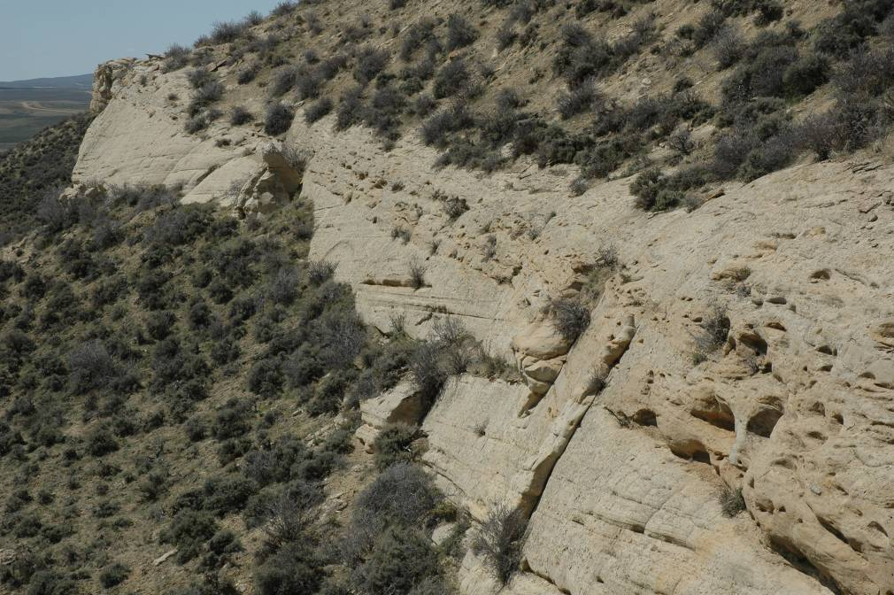
The Fox Hills river-dominated delta clinothems with overlying fluvial channel deposits

Keynote talks included the clinoform systems of the modern Ganges-Brahmaputra Delta, Amazon Delta, and Po-Western Adriatic Sea shelf clinoform system. ‘Ancient’ keynotes reviewed delta-scale and shelf-margin scale clinoforms. Modelers gave keynotes on experimental studies of clinoform patterns and on the modeling of fine sediment transport on shelf clinoforms. There was enthusiastic discussion after all talks. Two entire afternoons were given to the presentation and discussion of some 37 posters, the centerpiece of the Conference. During the two field days, relationships between delta clinoform steepness, facies/processes and grain size were examined in the spectacular Campanian Chimney Rock clinoforms of Minnie’s Gap, and in the Maastrichtian Fox Hills shelf-edge deltas of the Washakie-Great Divide Basin near Rawlins Wyoming. The challenge of taking 70 participants into the field went without a hitch.

The success of this Clinoform Conference came from the mixing of the three communities. From a brief ‘what did you learn’ poll of participants, those working ancient deltas were surprised by the amount of new knowledge on modern, muddy subaqueous deltas, and by recent breakthroughs in understanding wave-assisted sediment gravity flows on modern deltas. Modelers and those working the ‘modern’ gained insights on lowstand landscapes and deltas, and on the possible limitations of the highstand present to understanding the past.

