The idea of Crevassesplay.m

Suppose the channel ‘abcdefgh’ is the ‘real’ channel; the channel ‘abicejfgh’ is the conceptual rectangular channel which is of the same bank full discharge (Qfb) and channel cross section with those of the ‘real’ channel.

For the conceptual rectangular channel, delta_h is the average channel depth, Bc is the channel width, Bf is the width of floodplain.Using the relationship between hmax (the maximum channel depth for the ‘real’ channel) , Bc, and Qfb,hmax can be calculated.Since the area of yellow setion (Ax) should be equal to the area of blue section, X can be calculted. Thus the morphology of the ‘real’ channel is set.
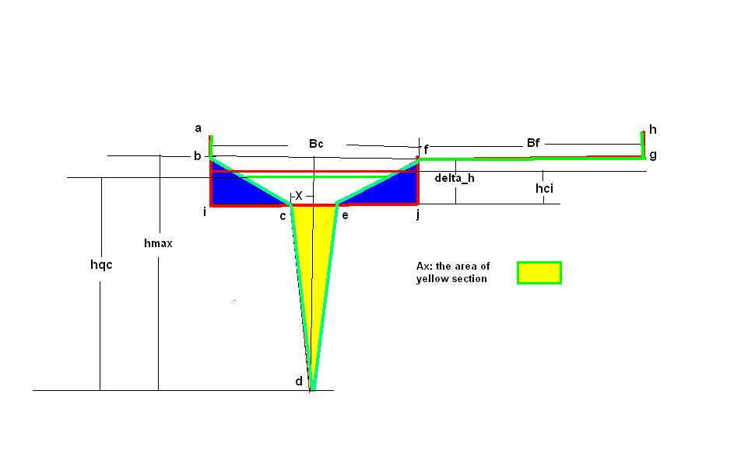
For a given water discharge Q, the water depth in the conceptual rectangular channel hci can calculated with the Manning Equation. Using the relationship that the cross section of water flow in the conceptual rectangular channel should be equal to that of water flow in the ‘real’ channel, the maximum water depth in the ‘real’ channle(hqc) for Q can be calculated.

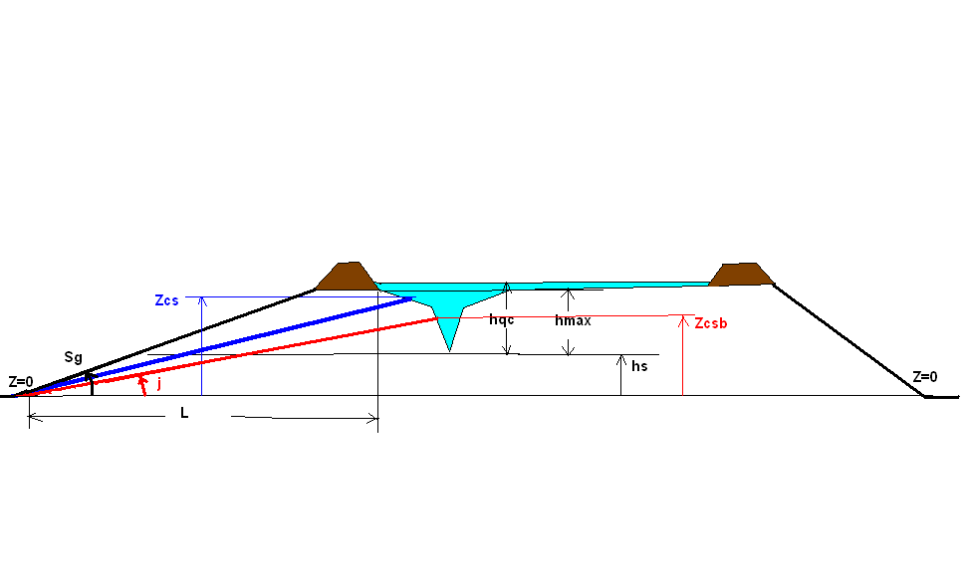
Zcs: the bottom elevation of crevasse slpay
Zcsb: the bottom elevation of a crevasse slpay whose flow slope is equal to the channel slope j
hs: superelevation (the elevation of lowest point of channel bed)
Z=0: the elevation of the ground beyond the floodplain (no floodplain sedimentation )is set to 0
Sg: the slope of ground from reference point for elevation to the dike or the edge of floodplain
j: the channel slope

The slope of crevasseslpay outflow should be no less than the slope of lower channel; and the bottom elevation of a crevasse slpay should be no lower than the the elevation of lowest point of channel bed, so the bottom elevation of the lowest point that a crevasseslpay is able to cut down is max(hs,Zcsb).

A ratio of Q above the bottom of crevasse splay (Qabove) can be distributed to outflow of crevasse splay. After flow parameters for the outflow of crevasse splay are calculated, the erosion (deposition) rate of crevasse splay can be calculated, thus the morphology of crevasse splay can be updated.

When the crevasse splay has not yet cut down to the lowest point max(hs,Zcsb), it can be both widened and deepened. When the crevasse splay has cut down to the lowest point max(hs,Zcsb), it can only be widened or silted vertically.

Notes: The model uses a simplified conceptual method. If the real relationships between the biggest channel depth and water discharge are available, just use the real relationship for the calculation of hqc and Qabove

