SedFlux Modeling - Using the CSDMS Modeling Tool

Explore Earth’s surface with community software

Much information about the CSDMS Component Modeling Tool (CMT) can be found on the CMT wiki portal: http://csdms.colorado.edu/wiki/CMT_portal

2.1 Set up the CSDMS Modeling Tool

These are three required steps:

Step 1 Activate your Secure Connection
You will need to have a VPN (Virtual Private Network) to have a secure encrypted tunnel from your computer to the University of Colorado's network whether you are on campus or off. Please install VPN-Network Connect Software on your own system. Find this software at the University of Colorado site:
http://www.colorado.edu/cns/vpn/
To then log in to the CU network, you will need to know your CU user name, and your password. Connect to the University of Colorado.
Step 2 Download the latest CMT tool
Download the CMT tool from the CSDMS website.
http://csdms.colorado.edu/wiki/CMT_download

Step 3 Start CMT and Log In to Beach
Double-click on the CMT icon.
You will be requested to log in to the CSDMS High Performance Computing Cluster (the HPCC is called Beach). You requested an account for this and received login information from us. For this step you will need again your CU user name, and password.

Step 4 Go to the CMT Workspace and Open TOPOFLOW Project
Now you are in the CSDMS Modeling Tool. It will automatically start up in the CMT Help, for the exercises we will use the ‘CMT Workspace’.

- Under the File Menu, choose ‘Open project’.
- Go to the Terrestrial Group. Open Project: TOPOFLOW + GC2D.

Now you are ready to import examples, adapt and run simulations
We will use the hydrological toolkit called ‘TOPOFLOW’ as an example to explore how CMT works, and what component modeling is all about.

2.2 Run and visualize a TOPOFLOW simulation

Under the File menu, choose ‘Open Example Configuration’. Here examples of previously wired model simulations are stored. These files are called *.bld files.

>> Open the directory for TOPOFLOW.
>> Find the subdirectory cmt_1.5.9
>> Click on the ‘bld’ file named: Treynor_June_20_67_Storm_May_27_11.bld

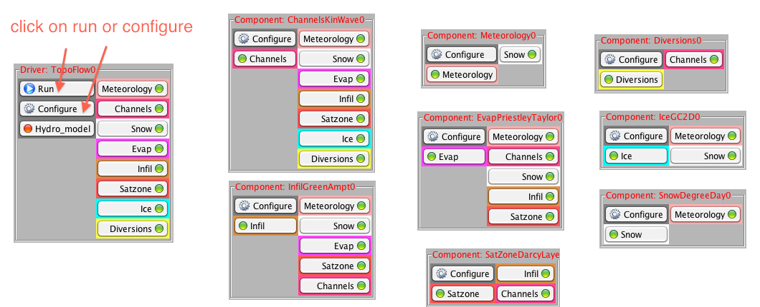

The Bld file brings up the pre-wired configuration as shown here. The TOPOFLOW component is the driver of this simulation. It needs to get values for all ‘Uses Ports’ on the righthand side of the component, i.e. meteorology, channels, snow…etcetera. The components in the Arena provide this information to the main driver.

This pre-wired TOPOFLOW simulation models a rainfall events in a small Agricultural Research Service watershed located near Treynor, Iowa. Data from Treynor watershed are ‘classic’ datasets that have become benchmark test cases for hydrological runoff and watershed models. The watershed was ~0.43 km², single-
Basin geometry parameters we will not be able to change in this hands-on. All parameters that are shown by default in the CMT for this TOPOFLOW Configuration are based on the benchmark data for a measured rainstorm on June 20th, 1967.

>> Run this simulation.
>> To get information on your run, go from the workspace to the Job Info space. There your jobs on Beach are listed with their ID’s and you can manage and query them.

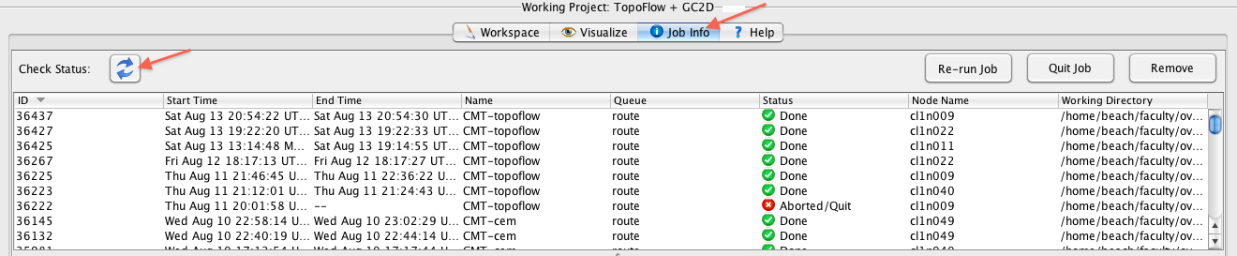

>> Highlight your topoflow job and click on the ‘Check Status’ button.
>> Basic information on this job will be reported in the console.

Question 1
What was the duration of this model simulation?
Why would hydrological models or runoff models not have a fixed time step?

Question 2
What was the maximum precipitation rate for this rainstorm?
What was the maximum discharge at the outlet for this rainstorm?

>> To get output from your run, transfer files from Beach to your local machine.
>> Under the tools menu, choose remote file transfer, port files from your Beach account to your local machine.
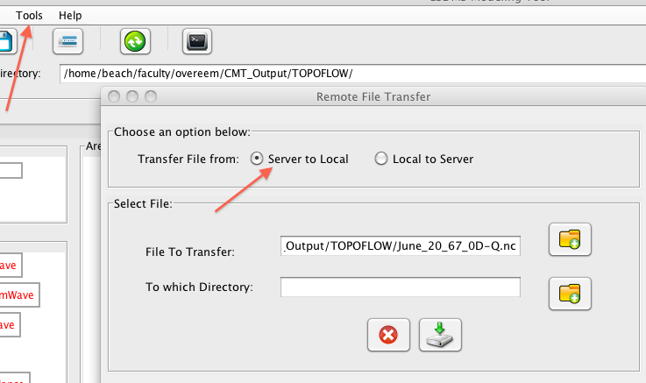
>> You now have the generated output files. The CMT tool generates the original ouput files as defined by the model developer. CMT generates NetCDF files as default format; these can be timeseries or grid stacks. You can visualize NetCDF files a.o. with VisIT.

More information on CMT and VisIT and notes on installation:
http://csdms.colorado.edu/wiki/CMT_visualization

>> Go to the Visualize space and launch VisIT.
>> Under VisIT, choose ‘Open File’ and open ‘June_20_67_0D_Q.nc’
>> This file will then show up as the Active Source.
>> You can use the Add button to add these variables to your plotting datasets.
>> Once you have added Q, you can use the ‘Draw button’ to plot a curve.

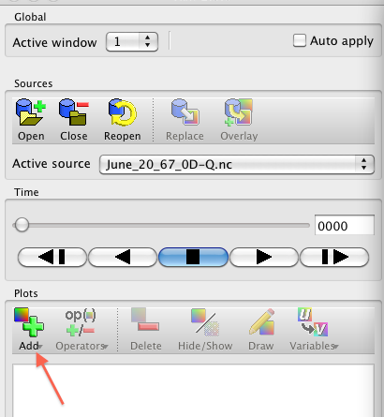

Question 3
What does the hydrograph for the June 20th, 1967 look like? What does the hydrograph look like in the upper part of the watershed? Plot both curves and export your figure. Does the maximum discharge match the reported maximum?

>> Under VisIT, choose ‘Open File’ and open ‘June_20_67_2D_Q.nc’

Question 4
Plot up this gridded variable. Use the play button to play it through the simulation time. What does the plot show?

Question 5
Why is it useful to simulate single rainstorm events?

2.3 Learn more about model theory and model manipulation

Sofar you have been running a TOPOFLOW experiment without looking at the model. Ideally you will not want to treat any model like that (ever). Models should not be a ‘black box’. In the next section we look at your options to peak into the machinerie of TOPOFLOW.

>> Under the File menu, choose ‘Open Example Configuration
>> Open the directory for TOPOFLOW.
>> Find the subdirectory cmt_1.5.9
>> Click on the ‘bld’ file named: Treynor_June_20_67_Storm_May_27_11.bld

>> Use the configure buttons to explore the settings of the different components.
>> Use the help button under the configuration menu to explore the background information of the different components

Question 6
Can you figure out from the configuration tabbed dialogues which components are being used and which are not in this pre-wired simulation?

Question 7
How is the in-channel water velocity calculated? Please write out the equation.

If you are an experienced modeler, you may prefer to download the original source code for TOPOFLOW. All source code of available models is shared through the CSDMS model repository:

Download of all models:
http://csdms.colorado.edu/wiki/Download_models

