CSDMS ‘JUST THE FACTS’
CSDMS Model Repository
The CSDMS Model Repository offers metadata and links to 167 CSDMS-related models and source code to 112 open-source models (e.g. basin evolution models, morphodynamics models, transport models, climate and ocean models) comprising 3 million lines of code written in ten languages.
Repository statistics as of July 2010:
Language | Projects | Comment | Source | Total
Fortran 77/90/95+ | 34 | 495246 | 1233292 | 1728538
c/c++ | 61 | 260715 | 918001 | 1178716
Python | 4 | 24840 | 23768 | 48608
MATLAB | 9 | 12338 | 27946 | 40284
IDL | 1 | 16730 | 18426 | 35156
Statistical Analysis | 1 | 2390 | 5796 | 8186
Java | 1 | 1107 | 6422 | 7529
Visual Basic | 1 | 537 | 5735 | 6272
Total | 112 | 813903 | 2239386 | 3053289
Model by Environmental Domain
88 Terrestrial models,
57 Coastal models,
27 Marine models,
46 Hydrology models,
3 Carbonate models.
Model code is downloaded ~2500 times per year. The top ten most downloaded models by version:
Model No. Times Topic
- topotoolbox 239 A set of Matlab functions for topographic analysis
- child 218 Landscape evolution model
- midas 192 Coupled flow- heterogeneous sediment routing model
- topoflow 162 Spatially-distributed, D8-based hydrologic model
- 2dflowvel 136 Tidal & wind-driven coastal circulation routine
- storm 92 Wind field simulator for a cyclone
- waveref 90 Wave refraction routine
- gc2d 72 Glacier / ice sheet evolution model
- stvenant 70 1D gradually varied flow routine
- bing 62 Submarine debris flows
CSDMS Data Repository
Data Repository Lists as of June 30, 2010

Data Type Databases
Topography/bathy 15
Climate 2
Hydrography 5
River discharge 5
Cryosphere 3
Soils 2
Land cover 2
Substrates 2
Human Dimensions 2
Sea level 1
Oceanography 1
Network Extraction 8
GIS Tools 12

CSDMS is actively working to add three new data holdings, all of which are still being added to, as new floods occur:
- Global Flood Atlas (digital GIS data showing flooded lands as observed via orbital remote sensing, and with associated recurrence intervals/exceedance probabilities for the inundation outlines)
- River Watch (estimated daily river discharge values from remote sensing for ~2500 sites, distributed along major rivers and tributaries on all continents, July 1, 2002 to present)
- Global Active Archive of Large Flood Events (catalog of flood events and associated attributes for each, such as geographic centroid coordinates for area affected, duration, calendar start and end dates, fatalities, severity estimates, etc: for 1985-present).

CSDMS Education & Knowledge Transfer Repository
The Education and Knowledge Transfer Repository offers undergraduate and graduate modeling courses, educational modules, modeling labs, and process and simulation movies. Model animations illustrate earth surface processes. Every animation has an associated fact-sheet with a short description of the animation.
Climate and Oceanographic Animations 15
Terrestrial Animations 10
Coastal Animations 5
Marine Animations 3
CSDMS Movie Gallery 16
Terrestrial Images 90
Coastal Images 47
Marine Images 2

Modeling Labs
"Landscape Evolution Numerical Experiments" W. Luo
"Coastal Stratigraphy Numerical Experiments" I. Overeem
Modeling Lectures
"Earth-surface Dynamics Modeling & Model Coupling" 7 lectures by JPM Syvitski
"1D Sediment Transport" 13 lectures by G. Parker
"Morphodynamics of Rivers" 15 lectures by G. Parker
"Geological Modeling" 7 lectures by I. Overeem
Modeling Textbooks
CSDMS works with modelers in the community who have published textbooks on modeling. We keep the associated code in the model repository so that it is easy to get for faculty and students alike.
1. Quantitative Modeling of Earth Surface Processes By: Pelletier, J.D.
2. Simulating Clastic Sedimentary Basins: Physical Fundamentals and Computing Procedures By: R.L. Slingerland, K. Furlong and J. Harbaugh
3. 1D Sediment Transport Morphodynamics with applications to Rivers and Turbidity Currents By: G Parker
CSDMS Experimental Supercomputer
The CSDMS High Performance Computing Cluster has been operating well, and has in recent days reached peak capacity by the 114 CSDMS members who have accounts on the system and have met the use criteria:
- Running a CSDMS model(s) to advance science
- Developing a model that will ultimately become part of the CSDMS model repository.
- Developing a new data systems or visualizations in support of CSDMS models.
The CSDMS HPCC is an SGI Altix XE 1300 that consists of 88 Altix XE320 compute nodes (704 cores, 3.0 GHz E5472 Harpertown processors). 64 of the 88 nodes have 2 GB of memory per core, while the remaining nodes have 4 GB of memory per core. The cluster is controlled through an Altix XE250 head node. Internode communication is accomplished through a non-blocking InfiniBand fabric. Each compute node has 250 GB of local temporary storage. All nodes are able to access 36TB of RAID storage through NFS. The CSDMS HPCC provides GNU and Intel compilers as well as their MPI counterparts (mvapich2, mpich2, and openmpi). The main power management is an APC UPS with 30 minutes of uptime at 50% load. The CSDMS head nodes are backed-up by a separate SGI installed UPS system. The HPCC is supported by the CU ITS Managed Services under contract to CSDMS.
CSDMS Community
There are 8 Working and Focus Research Groups, consisting of members from 76 US Academic Institutions, 17 US Federal labs & agencies, 63 Foreign Institutes in 24 countries, and 11 companies.
Membership in Working and Focus Research Groups as of 07/15/10:
Terrestrial 204
Coastal 142
Marine 110
Hydrology 110
Cyber 77
EKT 45
Carbonate 38
Chesapeake 27
Participating US agencies include: NSF, Office of Naval Research, Army Corps of Engineers. Army Research Office, U.S. Geological Survey, NASA, National Oceanic and Atmospheric Administration, National Oceanographic Partnership Program, Idaho National Laboratory, National Park Service, National Forest Service, U.S. Dept of Agriculture, EPA, Argonne National Laboratory, National Weather Service, Naval Research Laboratory, National Center for Atmospheric Research, Nuclear Regulatory Commission. A CSDMS Interagency Committee serves the function of both communication and coordination.
Industry Partners include: BHP Billiton Petroleum, Chevron Energy Technology, ConocoPhillips, Deltares, ExxonMobil Research and Engineering, Japan Agency for Marine-Earth Science & Technology (JAMSTEC), Schlumberger Information Solutions, Shell International, Petrobras, Statoil, and URS Corporation. These organizations collaborate via the participation of representatives in CSDMS committees and working groups, including a CSDMS Industrial Consortium.
CSDMS Personnel
New CSDMS staff:
Sagy Cohen (NASA post doctoral fellow)
Benjamin Hudson (NSF OPP Ph.D. student)
Fei Xing (NSF EAR Ph.D. student)
G Robert Brakenridge Director, Dartmouth Flood Observatory
Aaron Zettler-Mann CSDMS Undergrad student
Visiting Scientists or Students
- Hernan Arango Prof Marine Sci Rutgers University, New Jersey 2010 March
- John Gallant Prof Geol Sci CSIRO, Australia 2010 April
- Adam Campbell Ph.D. Student U. Washington, Seattle 2010 April
- Elchin Jafarov Ph.D. Student U. Alaska, Fairbanks 2010 April
- Vittorio Maselli Ph.D. Student University of Bologna, Italy 2010 May – June
- Silke C. Lutzmann M.Sc. Student University of Bonn, Germany 2010 March – June
- Juan Restrepo Prof Geol. Sci EAFIT University, Columbia 2010 July
CSDMS Publications since Jan 1, 2010:
Berlin, M, Overeem, I, McGrath, D, Rick, U, 2010, Regional runoff season duration from sediment plume analysis in the Kangerlussuaq area, Greenland, 40th International Arctic Workshop, 10 – 12 March 2010, Winter Park, CO, USA.
Brakenridge, GR, Syvitski, JPM, Kettner, AJ, Overeem, I, Sneddon, C, Fox, C, 2010, Predicted Effects of Future Dams and Levees on Flood Hydrology, Sediment Fluxes, and Deltas: Implications for Sustainable River Management. The Global Dimensions of Change in River Basins - Threats, Linkages, and Adaptations, 6 – 8 December 2010, Bonn, Germany.
CSDMS Brochure dated 2.12.10 (July 20, 2010, PDF format)
Kettner, A.J. Xing, F., Ashton, A. 2010. Are Human influences responsible for the existence and possible drowning of (parts of) the Ebro Delta, Spain? 18th International Sedimentological Congress, Mendoza Argentina.
Kettner, A.J., Overeem, I., and Syvitski, J.P.M., 2010. Deriving event scale discharge records from low resolution data. 18th International Sedimentological Congress, Mendoza Argentina.
Kettner, A.J., Restrepo, J.D., Syvitski, J.P.M., 2010, A spatial simulation of fluvial sediment fluxes within an Andean drainage basin, the Magdalena River, Colombia. J Geology 118: 363-379.
Kettner, AJ, Hannon, M, Syvitski, JPM, 2010, Simulating hourly discharge fluxes through the Niger delta. Eos Trans. AGU, 91(26), West. Pac. Geophys. Meet. Suppl., Abstract H31B-05
Kettner, AJ, Overeem, I, Syvitski, JPM, 2010, Downscaling discharge variability: can we predict daily flow characteristics based on annual flow characteristics? Eos Trans. AGU, 91(26), West. Pac. Geophys. Meet. Suppl., Abstract H32A-06
McCarney-Castle K., Voulgaris, G., and Kettner, A.J., 2010, Analysis of Fluvial Suspended Sediment Load Contribution through Anthropocene History to the South Atlantic Bight Coastal Zone, U.S.A J Geology 118: 399-416.
Overeem, I., Climatic Influences on Stratigraphy – Applications of Numerical Models. AAPG 2010, Abstract Vol, New Orleans, LA.
Overeem, I., Syvitski, J.P.M., 2010, Experimental exploration of the stratigraphy of fjords fed by glacio-fluvial systems, In: Fjords: Depositional Systems and Archives, J. Howe (Editor), Geological Society, London
Overeem, I., Syvitski, J.P.M., 2010, Shifting Discharge Peaks in Arctic Rivers, 1977-2007, Geografiska Annaler 92: 285-296.
Perillio, G, Picollo, C, Syvitski, JPM 2010. Delta geomorphology: is it in equilibrium with present day dynamic conditions? 18th International Sedimentological Congress, Mendoza Argentina.
Perillo, G, Syvitski, JPM, 2010, Mechanisms of sediment retention in estuaries. Inprint Newsletter of the IGBP/IHDP Land Ocean Interaction in the Coastal Zone 2010/1: 3-5.
Perillo, G.M.E., Syvitski, J.P.M. 2010. Mechanisms of sediment retention in estuaries. Estuarine, Coastal and Shelf Science (2009), doi: 10.1016/j.ecss.2009.10.026
Pyles, D.R., Syvitski, J.P.M., and Slatt, R.M., in press, Applying the concept of stratigraphic grade to reservoir architecture along the shelf-edge to basin-floor profile: an outcrop perspective, AAPG
Slingerland, R, Syvitski, JPM, 2011, Community Approach to Modeling Earth- and Seascapes. Treatise on Geomorphology, in press
Syvitski, J.P.M. 2010, Projecting Arctic Coastal Change. In: D.L. Forbes (Ed.) State of the Arctic Coast 2010, Scientific Review and Outlook. IASC/IPA/LOICZ, Potsdam. pg 89-92
Syvitski, J.P.M., E Grunsky, 2011, Recommended Protocols for Model Software Developers. Computers & Geosciences, in press
Syvitski, J.P.M., Peckham, S.P., David, O., Goodall, J.L., Delucca, C., Theurich, G. in press. Cyberinfrastructure and Community Environmental Modeling. In: Handbook in Environmental Fluid Dynamics, Editor: H.J.S. Fernando, Taylor and Francis Publ.
Syvitski, J.P.M., R.L. Slingerland, P. Burgess, E. Meiburg, A. B. Murray, P. Wiberg, G. Tucker, A.A. Voinov, 2010, Morphodynamic Models: An Overview. In: Vionnet et al. (eds) River, Coastal and Estuarine Morphodynamics: RCEM 2009, Taylor & Francis Group, London, ISBN 978-0-415-55426-8 CRC Press, p. 3-20.
Syvitski, JPM, 2010, Adventures of an explorer in the Canadian and Greenland Fjords. Program and Abstracts of the American Polar Society Meeting 2010, Institute of Arctic and Alpine research (INSTAAR), Univ. of Colorado at Boulder p. 20.
Syvitski, JPM, 2010, Both Sea Level Rise and Accelerated Subsidence put Deltas at Risk. Future Oceans, Kiel, Germany.
Syvitski, JPM, 2010, The Death of a Delta: The sad story of the Indus Delta. 18th International Sedimentological Congress, Mendoza Argentina.
Syvitski, JPM, Brakenridge, GR, 2010, Connection Between Floodplains and Delta Plains with Examples: Indus, Yellow and Niger. Landscapes into Rock, Geological Society, London.
Syvitski, JPM, Brakenridge, GR, Kettner, AJ, 2010, Divergent Flow of Water and Sediment in Lowland Coastal Settings. 18th International Sedimentological Congress, Mendoza Argentina.
Syvitski, JPM, Brakenridge, GR, Kettner, AJ, Overeem, I, 2010, Storm Surge Flooding of Deltas Made Susceptible by Human Activities, Storm Surges Congress (LOICZ), Hamburg, Germany.
Syvitski, JPM, Kettner, AJ, Hutton, EWH, 2010, Hyperpycnal Current-Sensitive Continental Margins, Eos Trans. AGU, 91(26), West. Pac. Geophys. Meet. Suppl., Abstract OS53B-01
Syvitski, JPM, Kettner, AJ, Hutton, EWH, 2010, Observing Coastal-Resuspension associated with Tropical Cyclones, Eos Trans. AGU, 91(26), West. Pac. Geophys. Meet. Suppl., Abstract OS54B-03
Syvitski, JPM, Kettner, AJ, Overeem, I, Hutton, EWH, Hannon, MT, 2010, Human and Natural Controls on a Delta’s Surface Elevation Relative to Local Mean Sea Level, AAPG 2010 Abstract Vol, New Orleans, LA p 251.
Voinov, C. DeLuca, R. Hood, S. Peckham, C. Sherwood, J.P.M. Syvitski, 2010, A community approach to Earth systems modeling. EOS Transactions of the AGU, 91(13): 117-124.

Progress on Year 4 Goals (April – July, 2010)
Goal 1) CSDMS Website ‘A Gateway into the CSDMS World’
The aim is to transform the website to an efficient, easy to use, gateway to the 3 core repositories with a fast portal to the CSDMS Modeling Tool CMT.
Milestones:
The CSDMS website offers the community as well as other CSDMS website users the possibility to stay up to date automatically of any newly added information in 4 ways:
- We have begun work on devising a simpler interface that promptly informs members and new CSDMS users what the Community Surface Dynamics Modeling System is all about, how to use CSDMS services, and how to become involved in the CSDMS community.
- Website has been partially redesigned as an efficient gateway into the three core Repositories that CSDMS maintains and develops, but still needs further development and testing. The focus of the redesigned website is to 1) provide simple straightforward access to the three repositories, 2) highlight new added material, 3) get new CSDMS members up to speed efficiently. Implementation is scheduled after testing has been complete.
- Each Repository is being set up in a database structure to allow for efficient searching, and retrieval of information and downloads. The model and data repositories are set up as a database structure, with an efficient search tool. As an example, the educational repository contains 5 sub categories (movies, images, labs, lectures, and textbooks), and is set up with an icon-based structure. Uploading of material is now greatly facilitated so that submission of EKT products, model, data and their metadata is both easy and fast.
- Fast portal for members to download the ‘CSDMS Modeling Tool’ (CMT), and within a few steps allow for the secure use of the CSDMS compliant models through the Ccaffeine Graphical User Interface for running models on the CSDMS HPCC. The newest version of the CMT is made available for downloaded or launch from the CSDMS front page (http://csdms.colorado.edu). A link to the CMT guide for developers and users is also available on the front page. CSDMS members have to request an HPCC account, which is stated on the login screen of the CMT as well as in the users guide, provided with a link to the HPCC account web form. The “Help” pages (http://csdms.colorado.edu/wiki/Help:Contents) provide a documentation section which contains the users and developers guide for the CSDMS Modeling Tool.

Goal 2) Usability of the ‘CSDMS Modeling Framework’
The CSDMS Modeling Tool is a key product of the overall project, as it allows earth scientists with relatively modest computer coding experience to use the CSDMS modules for earth surface dynamics research and education. On June 14, 2010, CSDMS announced our first official release of the CSDMS Modeling Tool, version 1.4. The CMT Tool has a MAC/Windows/Linux version, so there is basic platform independency.
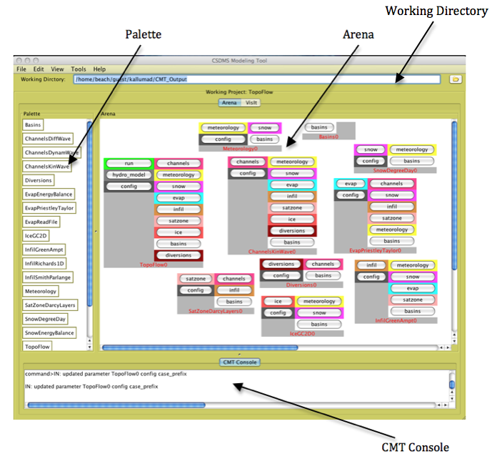
Figure 1. The window environment for coupled modeling; CMT Tool. Users can drag and drop the components from a Terrestrial Project environment, with a few mouse movements from the Palette of available components to the active working simulation; the Arena. The component connections and input-output are visually enhanced by color-coding the connections.

CSDMS Modeling Framework made user-friendly.
CMT 1.4 contains many features that make this tool user-friendly for both novice and expert users. A few of the features are listed below:
- Easy to start up: Improved Remote Access Functionality
  - Log-in screen bypasses SSH command line interaction of users
  - SSH tunneling via CMT
  - Straightforward capability of Sftp transfer of input and output files from server to local machine and vice versa
- Easy to click and work: Improved Look and Feel
  - Customizable background color and screen font
  - Component connections are color-coded so that coupling is visually apparent (Figure 1).
  - Wired and wireless options for creating models; wireless option can automatically connect components in the Arena.

- 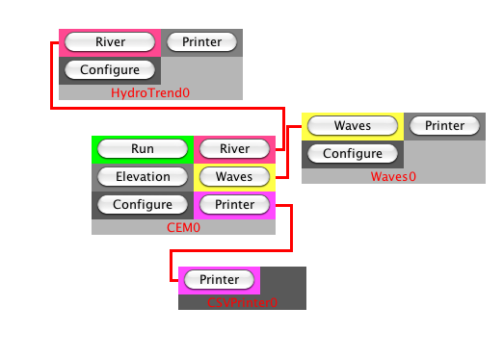
Figure 2. Zoom-in of a ‘wiring diagram’ for a coupled HydroTrend-CEM simulation. The HydroTrend model provides the river input; i.e. water and sediment load, this is subsequently used by the Coastal Evolution Model to simulate a wave-dominated delta evolution. Users can drag and drop the components from a Coastal Project environment, with a few mouse movements. Tabbed configuration menus allow the specification of simulation parameters. Click on ‘run’ and the coupled components will execute on the CSDMS HPCC Beach.

- Easy to debug and save multiple experiments: Improved Input/Output Operations
  - A Console window prints model run messages, these can be saved as log files for debugging.
- Easy save settings for new or multiple experiments
  - Open & Save Configuration of experiments so that re-runs of simulations are efficient
  - Import Example Configurations by loading tested ‘pre-wired’ example .bld files
- Usability for Advanced Users to quickly switch environments
  - Set default model
  - Option to Remove/Delete components and Clear Arena
  - Project Refresh & Reload options
  - Configure Dialog, to configure the input and output parameters and files for each model component
  - Preferences page
- Visualization Tool
  - Added access to visualization tool (VisIt) for output figures and movies
  - Changed input and output files of many components to have NetCDF capability to visualize through VisIT.
- Help has been added at Introduction level, at Example Configuration Level and at the Most Advanced Process and Parameter level (this aspect is further discussed under EKT).
  - Tutorials
  - Report a bug
- Help (About…)
- MAC/Windows/Linux versions
Facilitated non-expert users by developing clear and concise tutorials on the installation and use of the CSDMS Modeling Framework and integrated within the ‘Help’ system of the downloadable applications.
Getting Started: CMT 1.4 can be launched directly from the CSDMS website (through Java Web Start), or downloaded to the user’s computer as a java application (Mac, Windows, and Linux versions are available). Upon opening CMT 1.4, the user is prompted to enter their login information for the “beach” computing cluster. A link to the CSDMS website is provided at the login prompt if the user has not already obtained access to beach.
Upon logging in to beach, the opening screen of CMT 1.4 starts on the “About CMT” tab, which shows a general help page: Getting Started with the CSDMS Modeling Tool. This page briefly describes the purpose and development of CMT, and provides step-by-step instructions on how to start and login to CMT. The general layout of CMT including the Palette, Arena, and Console is described. This document also describes each of the commands on the menu bar. If the user navigates away from this page, the Getting Started document can be accessed from the Help menu (Help >> Getting Started >> General) or by clicking the About CMT tab (or by “^H”). Another “Getting Started” help page is available on how to create a model. This page briefly outlines the steps to build a model from scratch by opening a project within CMT and dragging components from the Palette into the Arena.
VisIt is a free interactive parallel visualization and graphical analysis tool for viewing scientific data on Unix and PC platforms. The CSDMS wiki contains detailed instructions on how to install VisIt for both Mac and Unix and PC systems (http://csdms.colorado.edu/wiki/Help:Ccaffeine_GUI#VisIt_-_Introduction). Once users have installed VisIt on their local machine, they may follow along with a brief tutorial “Getting Started” under the Help >> VisIt menu. This tutorial walks the user through the interface by which they can select model output files stored on beach, and visualize these results using VisIt. An additional tutorial under the Help >> VisIt menu, “Create Movie,” provides detailed instructions on creating movies using VisIt. In this case, the VisIt application is launched from beach rather than from the user’s local machine, in order to produce better quality MPEG movies.
Compliant CSDMS modules are given associated ‘HTML Help Pages’, listing vital information on the model processes and parameters stored within the Model Repository for download.
Upon opening a given project within CMT, users may choose to open example configuration files (in which all model components are already configured and made available in the Arena), or to drag components in to the Arena from those available in the Palette. Each component has a “Configure” button that will open a tabbed dialog box. From any tab within these configuration dialog boxes, the user may click the “Help” button to open an html help file. The help files are component-specific and provide detailed information on the processes, governing equations, and parameters for each model component, as well as relevant references.
Component-specific help files are currently available for TopoFlow and Erode model components. For components that do not have specific html help files yet (CEM and HydroTrend), the “Help” button connects to the model questionnaire on the CSDMS wiki. We are still working to provide links to documentation for the Water Tank, CHILD, Sedflux, and Waves components. All example configuration (.bld) files were tested to insure that they ran successfully and produced the correct output files; however, we did not extensively test different parameter combinations within the configuration settings. Note that .bld files were not created for the ODE or PDE components, as these are examples from the CCA Forum Tutorial.
Framework tested by non-experts who are not part of the Integrations Facility team.
Members of the Integration Facility team have conducted most of the framework testing. Aaron Zettler-Mann, a summer Research Assistant at CSDMS, has been running tests of the HydroTrend, CEM, TopoFlow, and WaterTank components and assisting in the development and troubleshooting of model tutorials. Vittorio Maselli, a PhD student from the University of Bologna in Italy and a member of our Marine Working Group, plans to assist in testing the SedFlux model components for his study of modeling of sequence geometry in the central Adriatic Sea.

Goal 3) Componentizing the CSDMS Model Repository
With the success of the model coupling proof-of-concept projects of Year 3, CSDMS engineers are converting, as time permits, user-contributed code into CSDMS plug-and-play components according to project needs and feedback from the working groups. Many low-level utilities are now in place that greatly simplify wrapping contributed models as CSDMS components.
The STM project is the set of Gary Parker's eBook, "1D Sediment Transport Morphodynamics" wrapped as CSDMS plug-and-play components. STM is a collection of models that deals with 1-dimensional sediment transport morphodynamics with application to rivers and turbidity currents. It includes 27 independent models covering various aspects such as Threshold of Motion and Suspension, Bulk Relations for Transport of Total Bed Material Load, 1D Aggradation and Degradation of Rivers, Morphodynamics of Bedrock-Alluvial Transitions, Approximate Formulation for Slope and Bankfull Geometry of Rivers, Plunging of Turbidity Currents and etc. Each model is now a CSDMS plug-and-play component with enhanced user-friendly graphical interfaces.
Work on ROMS, the Regional Ocean Modeling System, is underway with the goal to become a CSDMS component by the all-hands meeting in October. It will have tabbed-dialog GUI and HTML help pages.
ROMS is a free-surface, terrain-following, primitive equations ocean model widely used by the scientific community for a diverse range of applications. It is a modern code supporting serial and parallel computing. In its parallel part, both shared (OpenMP) and distributed-memory (MPI) paradigms coexist together in a single code. ROMS’s serial capability has been wrapped as a CSDMS component and can be run either from CSDMS’s CMT front-end graphic tool or from a command-line script. ROMS’s parallel code has been componentized and able is to run within an alpha version of CMT that can run components within an MPI environment.
Both serial and parallel computing environments have been built on CSDMS HPCC and they provide a consistent interface to CSDMS users. For example, a user can specify how many computing nodes and how many processors per node he wants for his simulation through CMT tool. The CMT tool generates scripts at two levels (component behavior level and HPCC job scheduling level) and run the model on the CSDMS HPCC.
The ESMF is a suite of software tools for developing high-performance multi-component Earth science modeling applications. It defines an architecture for composing complex, coupled modeling systems and includes data structures and utilities for developing individual models. Its infrastructure is able to map or regrind user-defined fields between structured grids and unstructured grids with the support of parallel computing. CSDMS developers extracted the mapping/regrinding functionality and wrapped it within a CSDMS component (called ESMF mapper). This enhances CSDMS’s potential to integrate and couple models that use different grid types and with increased grid sizes.
The Ashton Coastal Evolution Model (CEM) component (http://csdms.colorado.edu/wiki/Model_help:CEM) was enhanced to allow it to link with more components. It now communicates with wave and a stream routing components that provide incoming wave characteristics and water and sediment discharge over the delta, respectively. In addition, the user is able to configure more parameters for the CEM component through a GUI.
CSDMS developers created a wave component (http://csdms.colorado.edu/wiki/Model_help:Waves) based on the Ashton wave generator that was incorporated into the original CEM model. This component provides time-varying incoming wave angle as well as wave height, and length. It produces a directional wave climate through two main input parameters: asymmetry of incoming waves angle and proportion of high-angle waves. Although originally intended to couple with the CEM component, it provides wave characteristics that can be used by any component that uses such input.
The CSDMS IF staff componentized the avulsion model used within the larger sedflux model (called, Avulsion). This component routes one or more streams (along with their water and sediment) from a common “hinge point” to the coast. The partitioning of discharge between the streams is governed by rules based on streambed slope. Avulsion is used as a bridge between components that provide sediment and water discharge (HydroTrend, for example) and components that distribute sediment to a water body (CEM, for example). The configuration of CEM coupled with Avulsion is an example of a two-way coupling – CEM uses output from Avulsion (sediment discharge at river mouths) but also provides input to Avulsion (delta-plain elevation).
We have created and tested an ever-growing set of "pre-wired" CSDMS model configurations that can be used for (1) new users to use as working examples, (2) test suites and (3) educational materials

Goal 4) Advancing Goals of the Working Groups and Focus Research Groups
Completed a CUAHSI HIS "web service component" that can download hydrologic time series data and either share it through a CCA/IRF port with other components or write the data to files. It has a tabbed-dialog GUI and an HTML help page. Virtually the same code will allow us to create other web-service components, such as (1) an OpenDAP component (for grids and grid stacks) and (2) a component that can download a USGS NED (seamless) DEM for a specified bounding box.
Completed a set of low-level Python components for the Terrestrial Working Group that can perform fundamental DEM processing tasks like (1) filling depressions in a DEM, (2) extracting drainage networks, (3) computing slope grids and (4) computing contributing area grids. The fluvial landscape evolution model Erode that has been fully wrapped as a CSDMS component currently uses this toolkit.
Installed and tested the new, parallel version of TauDEM on beach, which also performs DEM processing tasks like those above, but using multiple processors.
SedFlux is being deconstructed into separate process components. The modules that have been separated out so far are plume, avulsion, subsidence and a 2D (vs.) 3D SedFlux component. The avulsion component is being incorporated into a new CEM-delta-avulsion project. Tabbed dialogs for these new components are under development.
A prototype of a new carbonate component has been written with an IRF interface but is not yet complete.
Abstraction of SedFlux's low-level data structures to create a "SedGrid" toolkit (for the Carbonate Focus Group) has begun, with a basic prototype expected by October.
A postdoc to work on the goals of the Chesapeake Focus Group will be hired in 2010.
EKT and CyberInfromatic Goals are discussed under Goals 6 and 7.

Goal 5) Conferences, Meetings, and a CSDMS Special Issue

CSDMS staff participated in the following meetings since the 2009 Annual Report:
01/2010 CSDMS ExCom Teleconference Boulder CO, USA
02/2010 NSF MARGINS Successor Planning Workshop San Antonio, TX, USA
03/2010 CSDMS Interagency Meeting Arlington, VA, USA
03/2010 NERC-NSF Critical Zone Observatories Arlington, VA, USA
03/2010 Arctic Workshop Winter Park, CO, USA
04/2010 Joint annual meeting of AAPG and SEPM New Orleans, LA, USA
05/2010 Climate Innovation Workshop Group, EPSCoR Valles Caldera, NM, USA
05/2010 BP Gulf Oil Spill Teleconference Boulder, CO, USA
05/2010 CSDMS ExCom Teleconference Boulder, CO, USA
05/2010 The American Polar Society meeting Boulder, CO, USA
05/2010 ONR Coastal Geosciences PI meeting Chicago, Il, USA
06/2010 The Western Pacific Geophysics AGU conf Taipei, Taiwan
07/2010 NSF CUAHSI Open Meeting Boulder CO, USA
07/2010 Desert Research Institute meeting Reno, NV, USA

Plans continue for the all hands CSDMS 2010 Meeting ‘Modeling for Environmental Change’ in San Antonio TX (Oct. 14-17). The meeting will bring together CSDMS members to present scientific insights in the modeling of surface dynamics and environmental change; new advances in cyber-infrastructure (CSDMS Model-coupling Tool, HPC techniques); development and use of CSDMS models in education (short clinics on EKT products); and allow the CSDMS Working Groups and Focus Research Groups to strategize on the direction of CSDMS for the next 5 years (i.e., the CSDMS Strategic Plan and Renewal.).
A CSDMS Special Issue of ‘Computers and Geosciences’ has been welcomed by the C&G editors.
Goal 6) Technical Advances in the CSDMS Cyber-Infrastructure
CSDMS staff has worked on a suite of cyber issues to aid the future direction of the CSDMS modeling environment, including issues related to semantics and ontologies.
Wrote new components to save time-indexed model output of four different types to NetCDF files. The types are time series (0D), profile sequence (1D, e.g. soil moisture profile evolving in time), grid sequence/stack (2D), and "cube" sequence (3D).
These NetCDF file describe data that is overlaid onto a rectilinear grid. Although a large majority of the models in the CSDMS repository use rectilinear grids, there are many that do not. Currently, there is no standard for representing unstructured grids with NetCDF, however we are working with Rich Signell and following progress of the UGRID community in developing a standard. In the meantime, CSDMS has created utilities that write unstructured grids to the VTK unstructured grid format. Both the NetCDF and VTK writers are written in Python but can be used within the CCA framework in any of the supported languages.
Modified virtually all of our existing model components to write their output to netCDF files using these new tools. Components based on unstructured grids now write to VTK format.
Coordinated with the developer of VisIt so that its "basic" netCDF reader can now read and display each of these 4 types correctly as a time-varying database.
One of the 4 new netCDF I/O tools is now CF compliant (as confirmed with an online compliance checker tool) and the other 3 will soon be compliant as well.
Completed a general tool that allows a tabbed dialog GUI to be generated automatically from a file that provides an XML description of the dialog. This allows developers to easily add or subtract which input items are available to the end user of the model component. This can be done quickly at run-time without needed to rebuild the component or project.
Completed a general tool that generates model input files based on user selections from the tabbed dialogs within CMT. This same text file also serves as a component's low-level configuration/input file (or files). This tool is written as a Python module and wrapped as a CCA component that can be used by components written in any of the supported languages. All of the CSDMS components now have tabbed-dialogs for input with a uniform look and feel.
All CSDMS components now have the ability to use separate directories for input and output. They also prompt for a "site prefix" and "case prefix" that they use to generate default filenames for output. The site prefix describes the location or study site and the case prefix describes the model run scenario.
Wrapped a powerful regridding tool that was developed within the ESMF project as a CSDMS component.
Added a tool to generate a simple, standard report upon completion when components are used in stand-alone mode. The report contains information such as run time and input/output directories, etc.
The CSDMS developers created a new utility that helps streamline creation of CSDMS-compliant components to be used within the CMT. The utility, written in Python, creates a new CCA component with the CSDMS interface necessary to link with other components. The component is created with boilerplate code that indicates locations where the developer is to insert implementation code for the particular model. As an alternative, the tool can automate this implementation step by reading a configuration file that summarizes how the developer wishes to implement the model. Although not out of alpha testing this tool serves as a proof-of-concept project for how component creation might be automated.
Goal 7) Educational and Knowledge Transfer
We envision the CSDMS Modeling Tool (CMT) will play an important role in making surface dynamics modeling accessible for student users. The beta version of the CMT has been launched with documentation for ease of use at a number of levels; ranging from general notes on installation, remote access requirements and software use on our wiki, to detailed notes on a certain parameter in a model equation within the menus of the relevant component. This documentation will undergo its own testing by a variety of users for clarity.
A new user will always be confronted with most general “Help System’ and instruction on ‘How to create a model run in a few steps’ (Figure 3). These concise learning modules help new students and other science users to get their first hands-on experience with the CMT Tool.

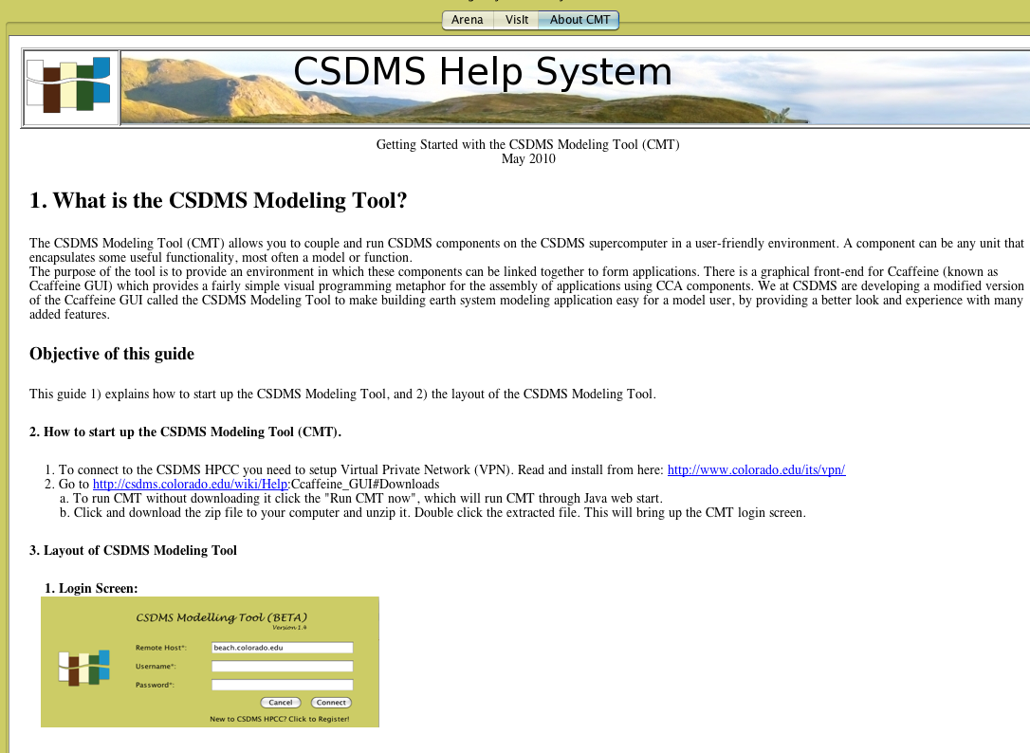
Figure 3. A new user will launch the CMT and then be taken to the first port of call; the ‘Getting Started with the CSDMS Modeling Tool’ guide.
The CSDMS Modeling Tool now includes all the relevant and in most cases multiple, coupled components to do simple model experiments. The following examples are launched in the beta version in July 2010:
1) Event-driven Precipitation influencing Landscape Evolution (CHILD or ERODE)
2) Valley Glacier Dynamics affecting Basin Hydrology (GC2D+TOPOFLOW)
3) Stratigraphic Architecture Storage Component (SEDFLUX 2D and 3D)
4) River Sediment Fluxes into a Wave-Dominated Coastal Environment (HYDROTREND + CEM)
Each of these coupled models or components now has enhanced documentation in the CSDMS Model Repository, and if manuals were available they have been incorporated, to make it easier for new users to familiarize themselves with the relevant models and their model theory and equations.

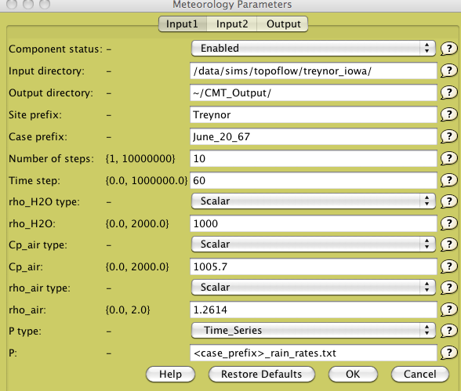

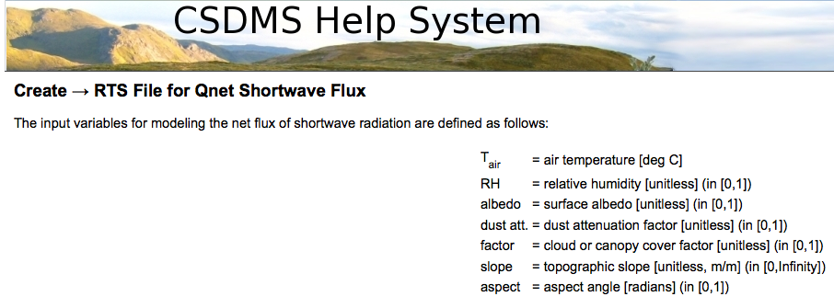
Figure 4. Example of a Model Configuration Menu of the meteorology component in the TOPOFLOW model. This configuration menu allows user experimentation with specific parameter settings. ‘Help’ buttons direct users to documented model theory and concise parameter descriptions.

Also, each example comes with at least one and more often several example files to import. These example files, so-called ‘bld-files’, have been tested both by CSDMS IF staff as well as by independent users. The CSDMS Help System (Figure 4) provides help with the scientific background of the coupling as well as an example simulation and its output (Figure 5).

We are further enhancing all these examples and will be developing the remaining examples in 2010. New model components have been prioritized and will be wrapped into the CSDMS Framework that will be critical for the subsequent science issues:
- Delta Dynamics affected by Human Perturbations
- Ice Sheet Melt feeding Coastal Plumes
- Global Wind-Driven Waves affecting Coastal Zones

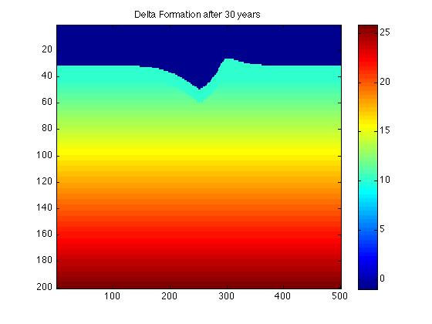
Figure 5. Documented out put from river-delta coupling. A. Time series of river bedload flux to the coast as predicted by HydroTrend over a single year. B. Planview of the grid shows the subarial part of the delta built out into the marine basin with this flux input (CEM model). The delta growth has been asymmetric, since the waves come in under an angle.

Inventory of Earth Surface Dynamics Modeling courses
The CSDMS Integration Facility staff is interested in making our products and tools accessible to the college classroom. Based on a recommendation from the EKT Working Group meeting in Fall 2009, we conducted a survey of university course catalogs to help us learn how surface process modeling is currently being taught. We targeted members of the Association of American Universities to gain a representative sample of research-intensive universities. 36 universities were surveyed; of these, 16 are also host institutions of CSDMS members. We required that either a geology or civil engineering department was required. Surveyed universities represent all regions of the United States, although the highest concentrations were in the Mid-Atlantic, Midwest, and Pacific Coast regions. Roughly equal proportions of private and public institutions were included in the survey. Undergraduate student populations ranged in size from less than 1,000 to over 75,000, and the graduate student populations varied between just over 1,000 to more than 14,000.
We reviewed course catalog descriptions and gathered information about courses that may be relevant to CSDMS, including basic details such as course name, department, level, credit hours, and format. We noted any required prerequisites, programming languages used, and the objectives from the course description. We also tallied which courses might be especially relevant to any of the CSDMS working groups or focus research groups. Course titles and keywords that were of interest include:
- modeling of earth surface processes
- GIS/remote sensing
- quantitative techniques/statistics
- sedimentary geology modeling
- hydrology/glaciology
- fluid dynamics
- groundwater hydrology/groundwater flow modeling/hydrogeology
- global change/climate modeling

For the 36 universities surveyed, we identified 1043 courses that had at least some relevance to CSDMS, in terms of subject matter or in the use of models. Geology/Geosciences and Civil/Environmental Engineering Departments had the most courses. In terms of relevance to CSDMS areas of interest, most connections were apparent to the Hydrology and Terrestrial groups. Matlab was the most common language mentioned in course descriptions, although Babel-supported languages were also present. If we focus solely on classes in which “modeling” is listed in the course description, such that these courses could directly use or benefit from CMT and other CSDMS Integration Facility products, the results are slightly different. Civil and Environmental Engineering departments become the most popular, largely due to the presence of groundwater and surface water modeling courses. From this survey, we can speculate that hydrology courses represent an opportunity for the immediate or near-term use of CSDMS products, and that civil/environmental engineering departments may be the most logical host of these courses.
An important caveat is that the results are only as reliable as the course descriptions in university catalogs, which may be out of date, incomplete, or inaccurate. We intend to administer a course questionnaire to CSDMS members as a way to validate some of our results. In addition we can then, identify common elements of these courses and experiences of instructors and students to inform the development of CSDMS educational modules. The full study is available below as Appendix 1.

CSDMS Short courses in 2010
We have identified several test-beds for courses and clinics among the different EKT user groups in 2010. Course material is developed based on the examples that have been launched in the beta version of the CMT July 2010 and its associated case studies.
Three EKT user groups are targeted:
1) Graduate students
The two winners of the CSDMS Student Modeler Award of 2009, Adam Campbell and Elchin Jafarov, have visited the CSDMS Integration Facility in April 2010 and spent time with the CSDMS Integration Facility staff to get instruction on the use of the CSDMS Modeling Tool and to explore possibilities for use of the CSDMS Modeling Tool in their own research projects. They received instruction on the HPCC system use as well.
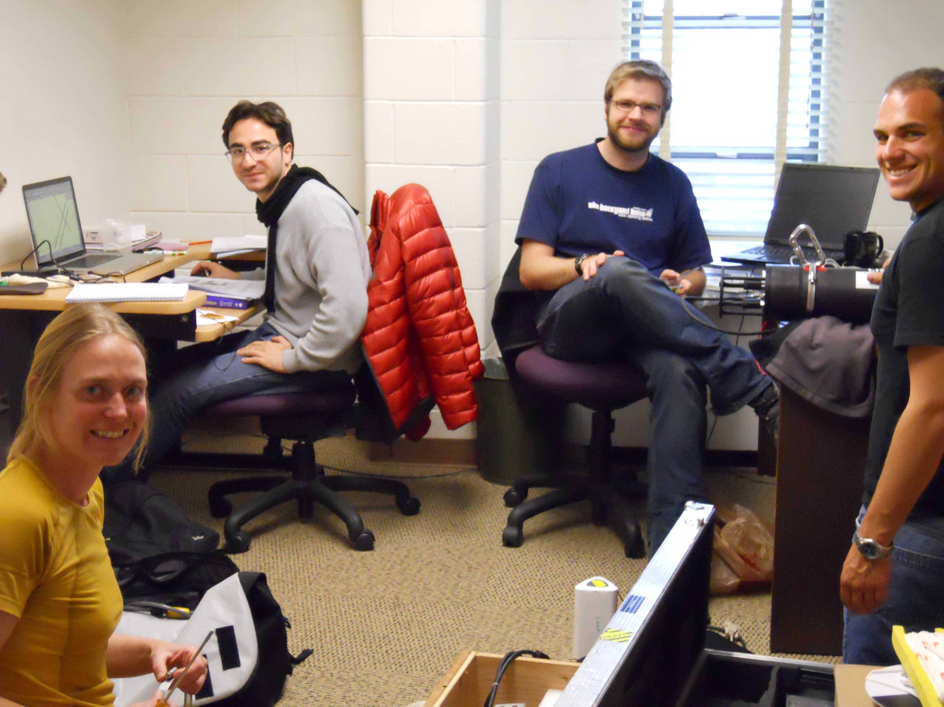
Figure 6. Visiting scientist Vittorio Maselli with CSDMS Ph.D. student Benjamin Hudson, and recently graduated student Aaron Zettler-Mann who are preparing for fieldwork up in Greenland with PI Dr. Irina Overeem.
CSDMS IF staff is teaching a new graduate level course in the Fall Semester 2010 at CU Boulder: ‘Surface Process Modeling: Applying the CSDMS Modeling Tool’. This 2 credit course aims to familiarize earth sciences and engineering graduate students with a number of numerical surface process models and hydrological models available through the Community Surface Dynamics Modeling System and set them up to use these tools for own research purposes. The course may be used as a ‘use-case’ for the NSF-funded project, “Scaling Up: Introducing Commodity Governance into Community Earth Science Models.” This course will provide an immediate opportunity for evaluating how our current cyberinfrastructure can support the course’s educational goals. See the initial use case description below as Appendix 2.
2) Science users outside of the core CSDMS community
CSDMS is providing a short course on models and model coupling at a conference of Future Oceans, Kiel, Germany Sept 11, 2010.
3) CSDMS Industry partners
CSDMS is providing a short course on stratigraphy models and sediment supply models as well as model coupling, targeted to a specific example for industry partners in both August and September 2010.
4) K6-12 Students
CSDMS participated in the INSTAAR Open House. The INSTAAR Open House hosts over 170 middle school students every year, they participate in hands-on science measurements and activities. The CSDMS Integration Facility team set out to teach concepts of super-computing. To illustrate parallel processing, versus fast-processing students raced to perform tasks as ‘fast processors’ or cluster teams’ and gained insights on basic supercomputing strategies. They toured the HPCC facility and experienced first hand how heat is generated from the many calculations performed by the supercomputer.

Solicit feedback from CSDMS members through the website on their experiences with using the CSDMS Modeling Framework.

All CSDMS members received an announcement of the first official release of the CSDMS Modeling Tool (CMT), version 1.4. In addition to explaining how to get started with CMT, this email also listed options in the CMT Help menu, including “Report a bug” as a way to provide feedback through the CSDMS Track page. Selecting the “Report a bug” option opens a dialog box, in which users may choose whether to create a new ticket for the bug they have discovered, or to view all active tickets. Users may contribute these bugs without needing to log in to the CSDMS Track page; however, they must provide their email address if they wish to receive replies or updates regarding the bug.

The form for entering a new bug requests a brief description of the bug, which in the CMT dialog box is explained as:
- Please explain your problem in detail
- The steps you did to hit the bug, needed for us to reproduce it
- What results did you get or else you could copy the log under CMT_Files
- For replies or updates please include your email address while creating the ticket or use RSS feed
The Track form also asks the user to characterize the bug as a defect, enhancement, or task, and to assign a priority to the bug.

Currently, each time a model is run on beach using CMT, a log file is generated that records the contents of the .bld file, indicating the configuration settings of the model run. These log files are accessible to CSDMS IF staff. Based upon the time of the run and the model name indicated in the log file, we should be able to match these log files to any Track tickets based upon the details that are provided by the user. As more users gain access to beach and begin using CMT, the log files will be useful in troubleshooting model problems as well as bugs within the CMT.

