Sandbox Experiments on Rivers and Vegetation

Developed by Irina Overeem, Mariela Perignon, and Greg Tucker
Community Surface Dynamics Modeling System, University of Colorado, Boulder, CO

Overarching Objective
- Perform an experiment
- Collect and analyze data
- Compile measurements and create a report and/or presentation

Topical Objective
- Learn about the impacts of vegetation on the physics of water flow and river sedimentation
- Learn about interaction between the biosphere and hydrosphere

Grade level: 6-12th grade

Materials: water hose, plastic basin (see description in Experimental Setup), hose, flow diffuser (see description in Experimental Setup), fine play sand, steel wool, very thin sticks, graduated buckets, rulers, protractors, wooden blocks or bricks to prop up basin, optional: food coloring, timer or stopwatch, duct tape.

Time required: 2-3 class periods

Science standards: scientific inquiry, design and conduct scientific investigation, hydrological cycle, complex interaction between geosphere, hydrosphere and biosphere.

Introduction on Rivers and Vegetation
These sandbox experiments are inspired by the Rio Puerco, an arroyo (a dry creek or gulch) in New Mexico, but the processes seen in the experiment are similar to those in many rivers in the southwestern US. The Rio Puerco is dry for most of the year, and most of its flow comes from flash floods during and after intense summer rainstorms within its drainage basin. The Rio Puerco is a tributary river to the Rio Grande, the lifeline river of some of the driest regions of New Mexico, western Texas and northern Mexico. In the 1920s and 1930s, the Rio Puerco was recognized as the source of high volumes of mud, silt, and sand into the Rio Grande. This sediment was causing the Rio Grande to jump out of its channel during floods, damaging nearby towns, and was quickly infilling the large Elephant Butte Reservoir downstream and threatening the long-term water supply. The flows of the Rio Puerco had always been known to be muddy -- even its name, ‘Pig River’, may have originated from its dirty waters. To reduce the volume of sediment that the Rio Puerco could erode from its catchment and transport downstream, an exotic (non-native) plant, tamarisk (also known as Salt cedar), was introduced to the area in the 1930s. Since then, much of the native vegetation that naturally populate the floodplains (such as sandbar willows and cottonwoods) has been replaced by a thick forest of the invasive tamarisk. The spread of tamarisk along many waterways in the western US is an important problem for environmental managers because this non-native species consumes large volumes of water, increases the salt content of the soil along rivers, prevents native plants from growing on the floodplains, and damages the habitat of many wildlife species. Tamarisk has also caused the rivers to change shape, turning their wide, shallow channels that could easily move from side to side into narrow, deep meandering channels that are immobile.

This sandbox experiment looks at the processes that determine the geometry of rivers, the effect of vegetation on the shape of channels, and the impact of floods on the landscape.

In this experiment, we mimic the flash floods that affect sandy rivers in arid regions by introducing sudden flows of water and sediment at the top of the sandbox landscape.

Questions for deeper thinking:

- What do rivers in arid regions look like?
- Where does river water come from? What factors affect the volume and speed of river flow?
- How do trees and bushes influence the flow of rivers and the location of river erosion or sedimentation?
- How does the shape of channels evolve during low flows? What is a flood, and what do rivers look like after a flood? Why are floods and low flows different?

After an initial discussion with the whole class about the characteristics of rivers and the effects of floods on channels and floodplains, students can identify multiple factors that might determine what a river looks like and how it evolves over time. For example:

- slope of the river bed (ex: mountain streams vs. rivers on the plains)
- river discharge (ex: a river at flood vs. a river at low flow)
- density of plants on the floodplains (ex: lots of trees very close together vs. a few trees far apart)
- type of vegetation on the floodplains and channel banks (ex: grasses, shrubs, or trees, many thin stems vs. a few thick trunks)

Each of these characteristics should be explored independently. Students can select one factor for the list and formulate a hypothesis about the effects that changes to that factor could have on a river. They then design an experiment using the sandboxes to test their hypothesis.

It is important to discuss with students the need for controlled variables (variables that are constant) in experimental design. For example, an experiment that changes both the slope of the basin and the volume of water flowing into the river will not be allow to isolate the control factor that caused any changes in the geometry or behavior of the experimental river.

Experimental Setup

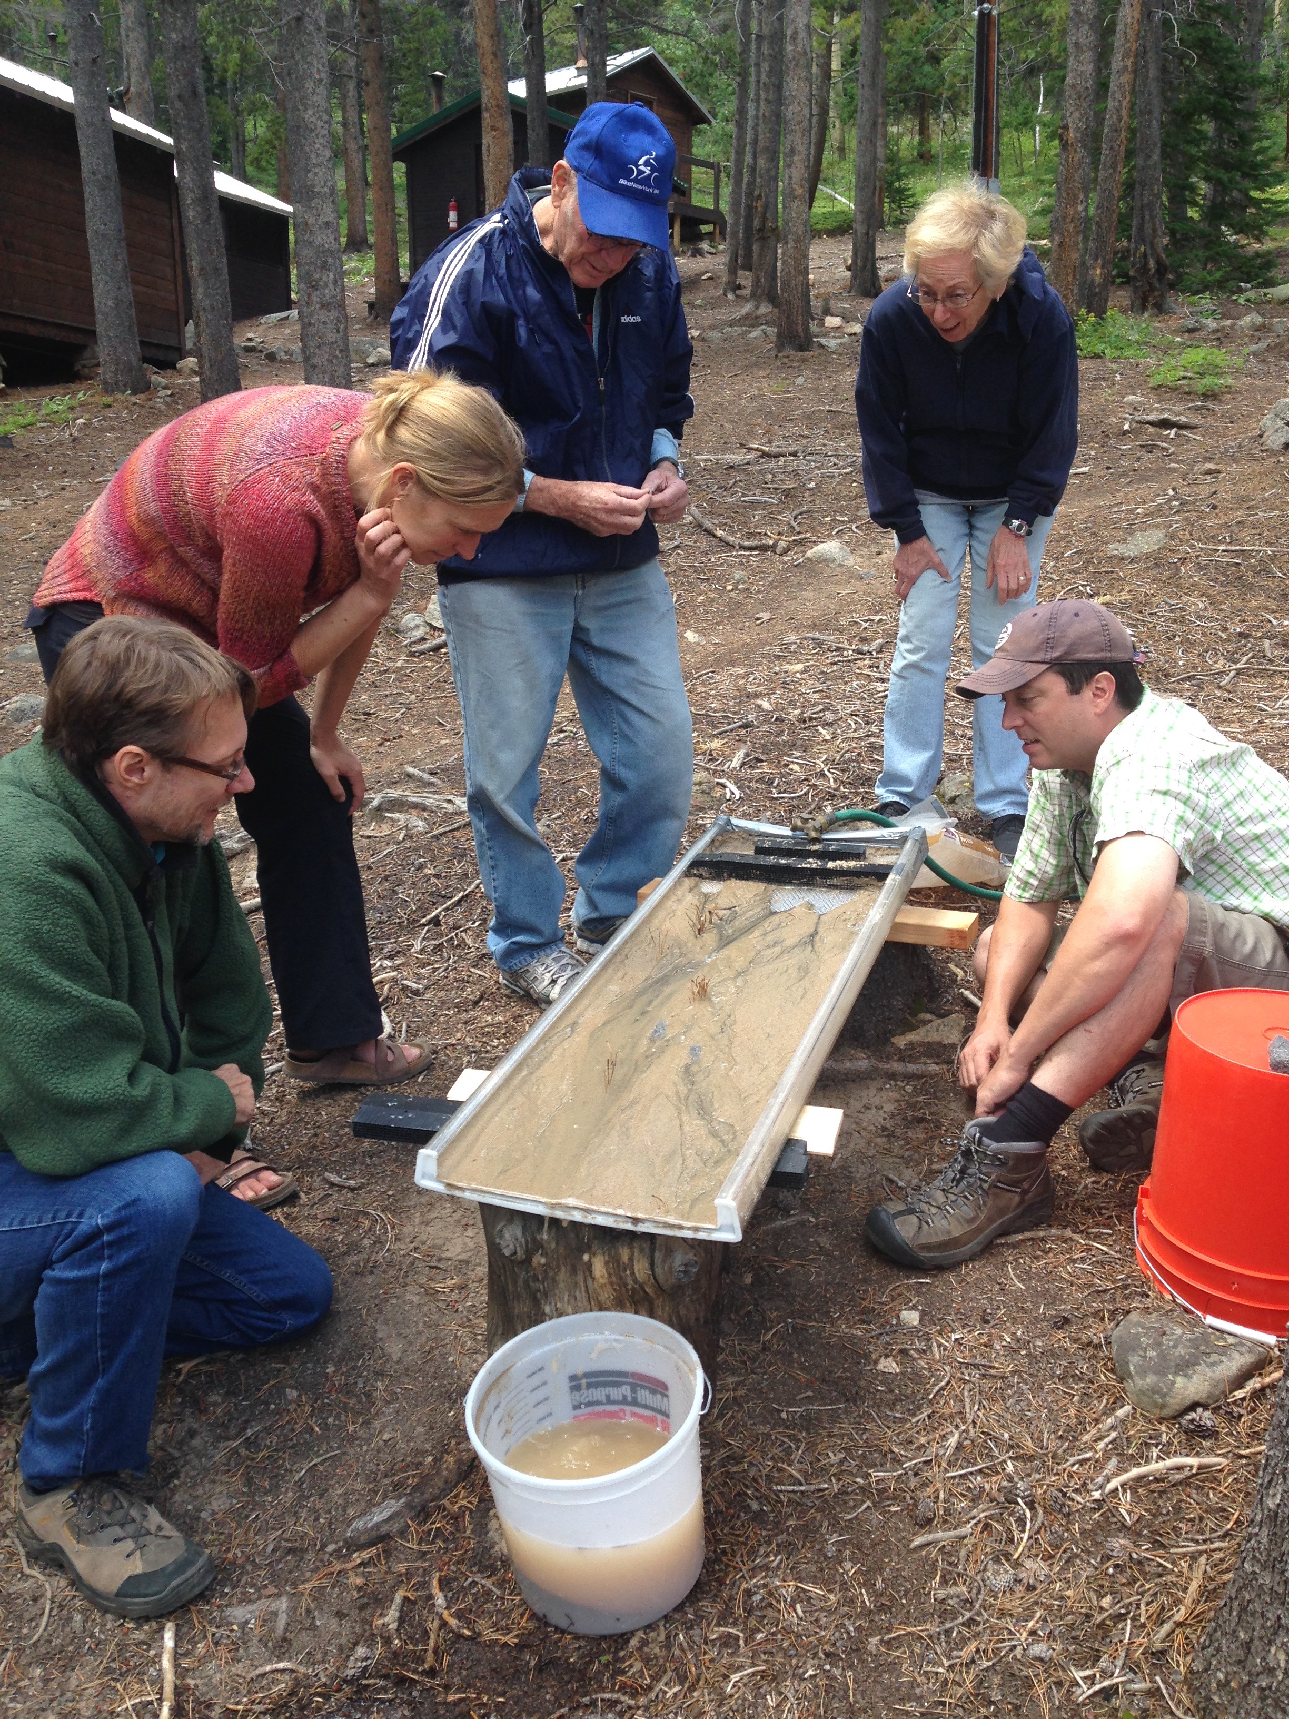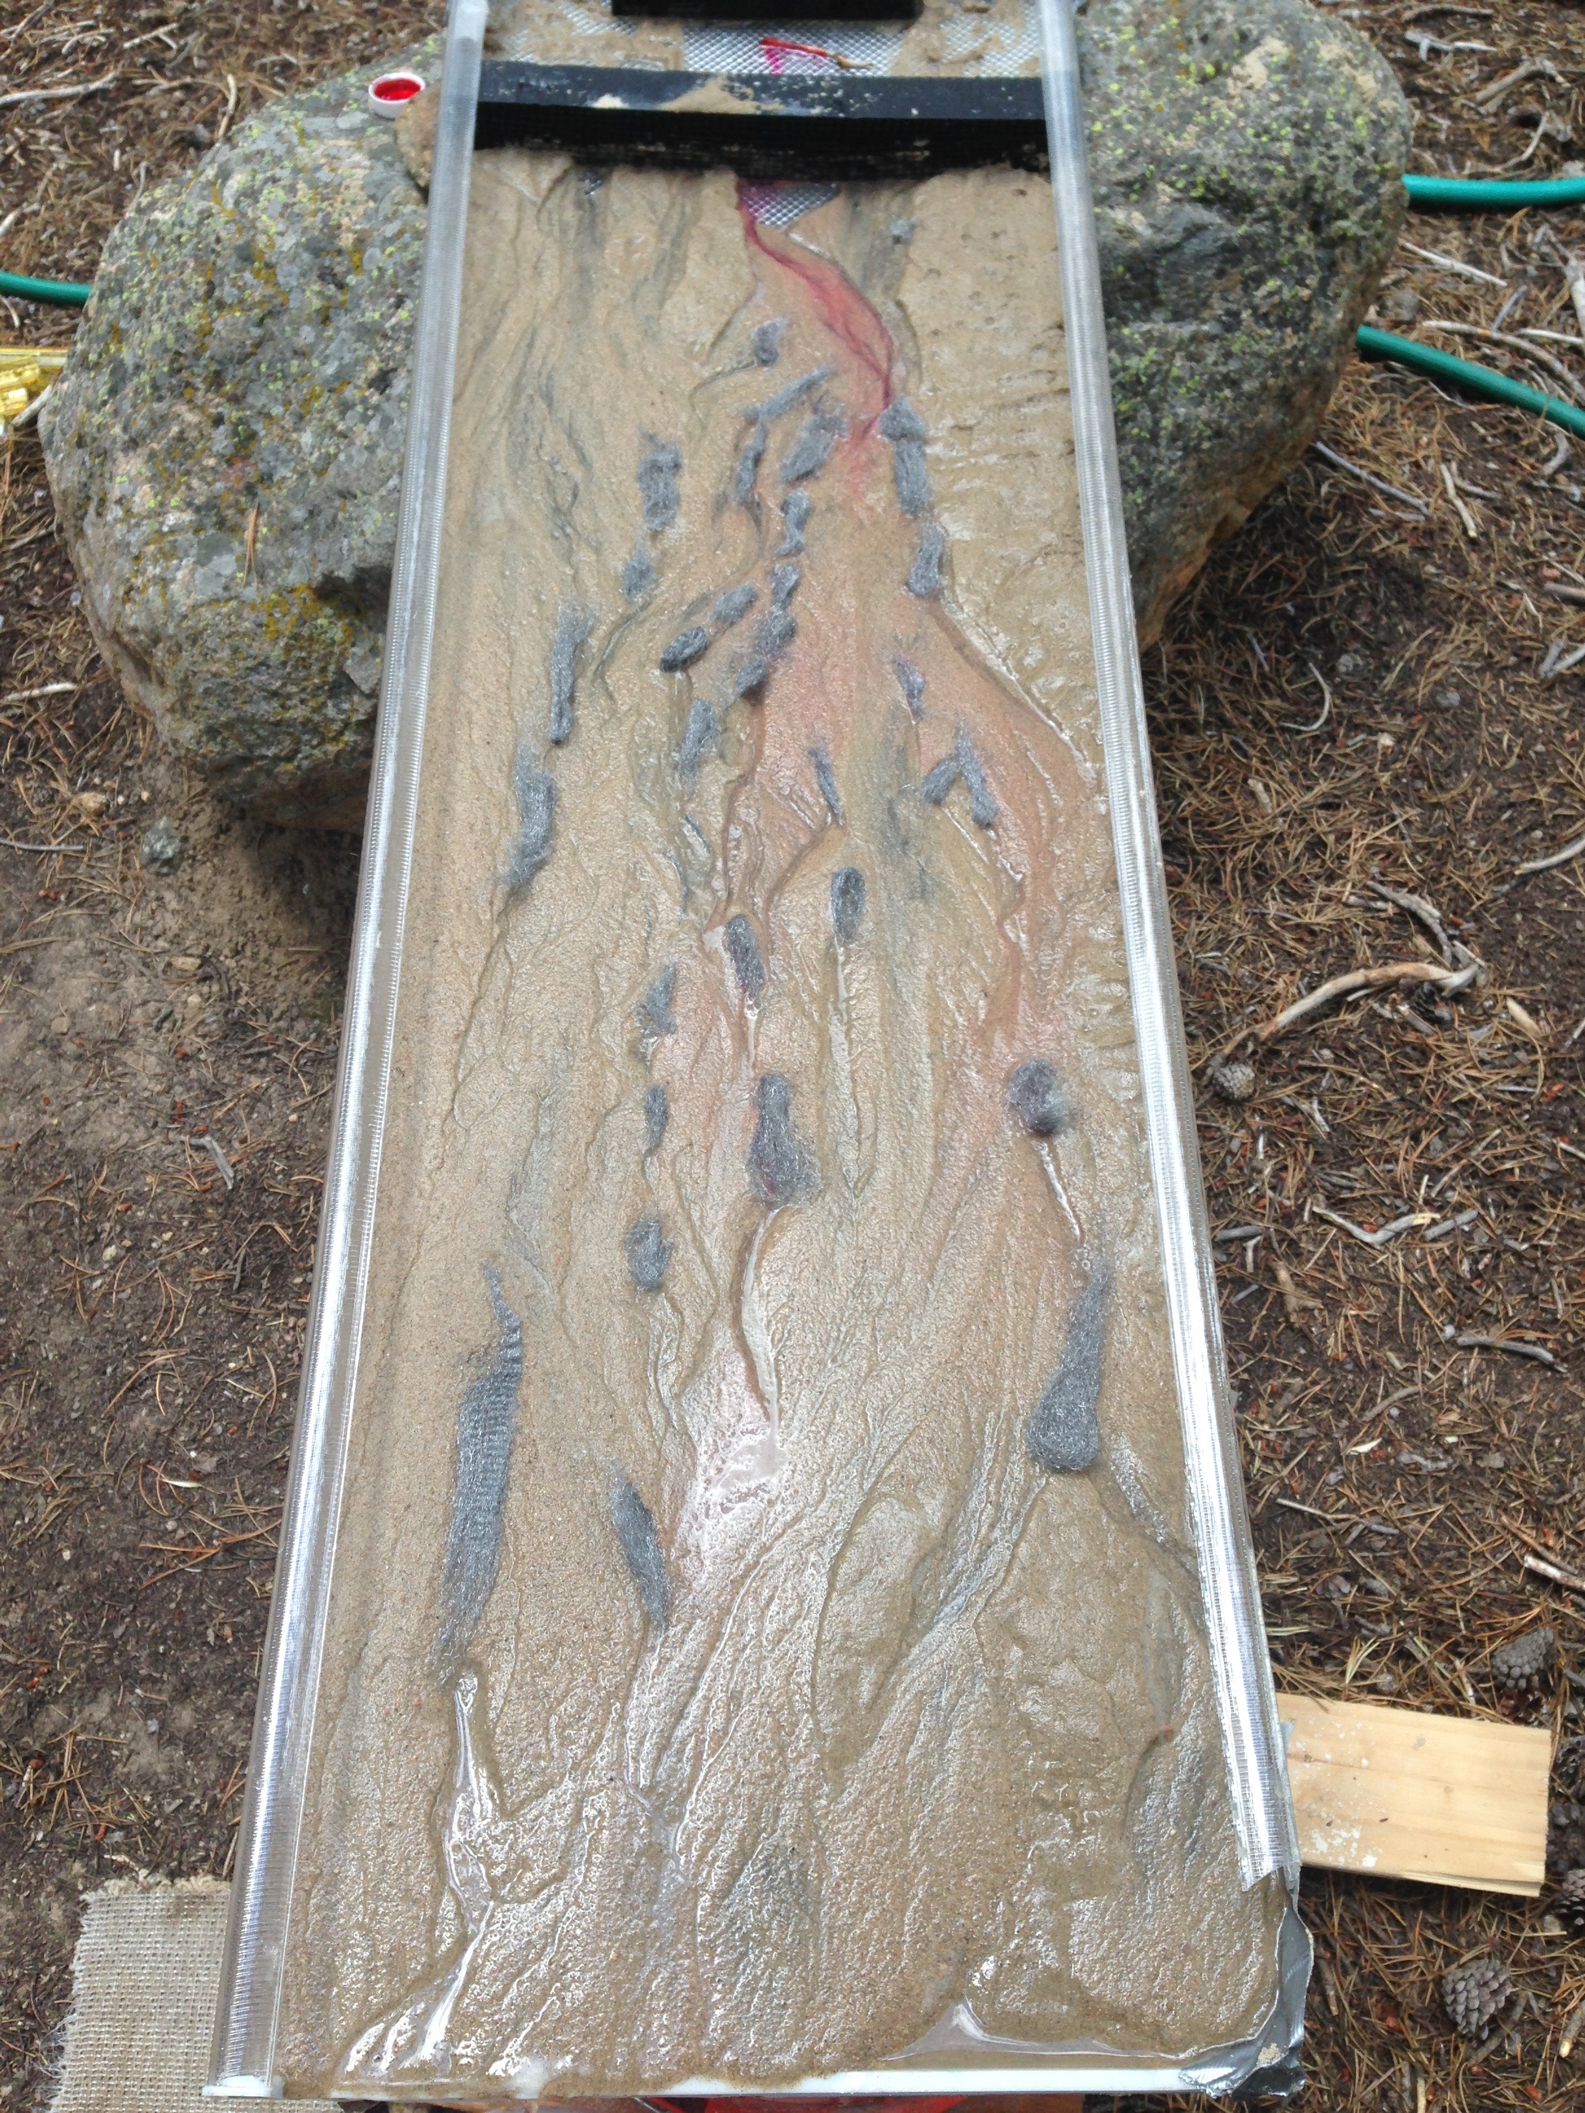

We intend for this experimental setup to be built primarily of materials that are inexpensive or can be obtained for free. These photos show one example of the experimental setup, which we built using repurposed building materials and play sand. The experimental setup should include:

- A basin to serve as the artificial river valley. We used the plastic cover of a fluorescent light fixture of approximately 4 by 1,5 ft. The upstream end of the basin should be sealed to allow for water to back up. We created a make-shift wall for the upstream end of our basin with duct tape. The downstream end of the basin remains open to allow water to flow out of the basin without ponding.
- Fine sediment to fill the basin. We used fine play sand purchased from a hardware store. Material that is well sorted (all grains are of the same size) will work better than sediment with a mix of grain sizes.
- Wooden blocks to prop up the basin. The slope of the basin should be very low, basically flat. This slope can be varied by propping up the upstream end of the basin on a 2x4 piece of lumber, lying flat.
- A bucket to capture the water and sediment flowing out of the basin. A graduated translucent bucket works best, but any large plastic container can be used. Sand should not be allowed to flow down a drain but should instead be captured in a bucket. The bucket can be placed on a scale and then water /sediment fluxes can be calculated for the more advanced classes.
- A hose. The flow of water should be very slow, like a drip irrigation system, even while simulating floods. Water should be at most a few millimeters deep within the basin, and much of the basin should have no water flowing over it. We used a garden hose fitted with a hose splitter that gave us finer control over the flow.
- A filter to diffuse the flow. The purpose of this filter is to distribute the water from the hose more evenly across the width of the basin and to minimize turbulence in the flow. We used a filter intended for rafter vents that span the width of the basin and had many small parallel tubes throughout the filter. This is a specialized construction material that is not easily found in hardware stores. Other options include creating a porous wall from large pieces of gravel or from a bundle of netting like a shower puff, or releasing water through a hose with multiple small perforations set across the width of the basin.
- An analog for vegetation. This material should consist of many closely spaced thin filaments or rods that simulate bundles of plant stems or branches. We used both clusters of small dowels (thin sticks or pine needles) and steel wool.

Optional materials:
- Food coloring can be used to observe the path and depth of flow in the sandbox. Red or pink food coloring works best with light colored sand. We dipped the tip of a thin dowel in bright pink gel food coloring and held it at the outlet of the hose, dying the water pink. Gel food coloring dissolves slowly, making it possible to have dyed flow entering the basin for tens of seconds. However, it stains clothing and skin very easily. Liquid food coloring is easier to introduce to the flow but only colors individual pulses of water.
- Smart phones or cameras set on a tripod can be used to record video or time-lapse photographs of the evolution of the basin. Placing a clock within the frame of the image is an easy way to include the elapsed time in a time-lapse video.

Experimental methods:

The students can discuss potential experiments for exploring the importance of each of the factors controlling the geometry and behavior of rivers. They should remember to only change one variable at a time and control the rest.

- Slope: The slope of the basin can be measured using protractors (the angle that the basin makes with a flat surface), rulers (rise over run), or an inclinometer. There are many smart phone apps for measuring angles that can also be used if they their resolution is high enough. The basin should first be set at a slope where sediment is just barely being moved by the flow. Decreasing the slope of the river (without changing the flow rate) would then stop sediment from moving, and increasing the slope would increase the rate of sediment transport. It should not be necessary to change the slope of the basin much to notice a difference.
- Discharge: Discharge is a measurement of the amount of water carried by a river. It is the product of the flow velocity, the width of the flow, and the depth of the flow. It is not possible to independently increase the velocity or the cross-sectional area of the flow for a channel with a certain shape and slope. Changing discharge requires changing the rate at which water in introduced into the basin either by manipulating the hose or the velocity at which water is poured from a container of known volume. In the sandbox, discharge can be obtained by either calculating the rate of flow of the input (the time it takes the hose to fill a certain volume, for example) or at the outlet of the basin. For the latter, it is important to consider the volume that sediment might be taking up in the container. It is also possible to measure the velocity of the flow in the sandbox by timing the movement of the front of a streak of food coloring or a floater (such as a small Styrofoam pellet) down a section of channel of known length.
- Vegetation: Vegetation imposes a drag on the flow and reduces the velocity of the flow, leading to sedimentation. Once a river network has been established in the sandbox, small patches of vegetation can be introduced by placing an analog such as steel wool in the basin. The experiment will respond most realistically if this material is placed in areas where vegetation would naturally establish such as the inside of channel bends and in mid-channel bars where the flow is very shallow and slow. Students can gradually add more patches of vegetation to the sandbox and observe the effects that vegetation density has on river geometry. They should be instructed to wait a few minutes every time they add vegetation to give the experimental river time to respond. It is also interesting to focus observations on a few patches of vegetation and identify their impact on the movement of sediment and flow. Students can explore the effects of different types of vegetation by placing patches with different types of materials (steel wool, closely spaced toothpicks, more sparse toothpicks, etc) in similar areas of the basin and observing their effects on the river. (Note: It is possible that students will find that a particular spacing of stems increases erosion instead of causing sedimentation. This is a very important observation of a real phenomenon – by narrowing the path of the flow, a few widely spaced stems can accelerate the flow enough to negate the effects of drag. This is the phenomenon that leads, for example, to bridge scour due to erosion between piers).

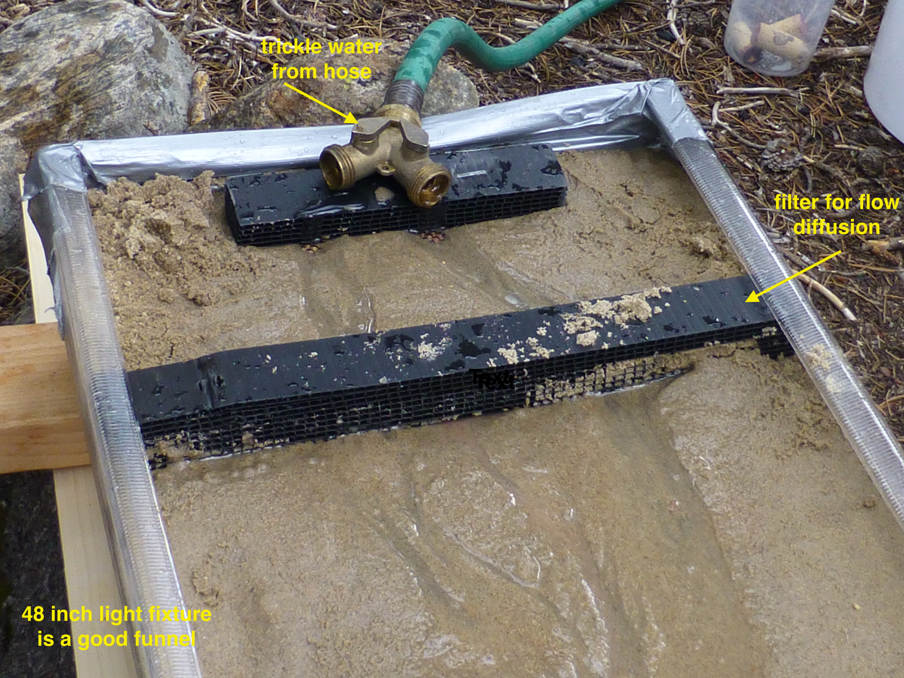
Example of an experimental setup in more detail, the amount of water introduced can be varied to study the effect of a peak flow. Flow diffusion is important to introduce the water into the ‘river floodplain’ gradually.

Data collection

It should be encouraged that students make data tables of the experimental setup, and the changes in the controlling variable. Then, in additional column(s) the measurements can be listed (and graphed later on).

Example Table 1

Name of Experiment: effect of bushy vegetation
Hypothesis: ……………..
Description of experiment: ……….

Amount of vegetation | Flow velocity (m/s) | Flow width (cm) | Notes
No vegetation
Very little bushes (2% of the total area)
Some bushes near channel edges (5%)
Many bushes in river floodplain (20%)

Reporting
Depending on the level of the students: a report can be written for each set of executed experiments per small group. Alternatively, the teacher can reconvene all groups after all experiments have been completed, and discuss everyone’s results. Data can be exchanged and a joint report about the effects of several controlling factors can be compiled

